Local Care Record
Your local NHS organisations in Southwark and Lambeth have a duty to keep complete, accurate and up-to-date information about your health, so that you can receive the best possible care.
Sometimes the people caring for you also need to share some of your information with others that are also supporting you. This could include GPs, hospital based specialists, nurses and health visitors.
To support this information sharing to happen more quickly and to improve the care you receive, a new process has been put in place in Southwark and Lambeth. This will join-up your care records from your local hospital organizations (Guy’s and St Thomas’, King’s College Hospital and South London and Maudsley NHS Foundation Trusts) with GP practice information through existing computer systems. It is called the Local Care Record.
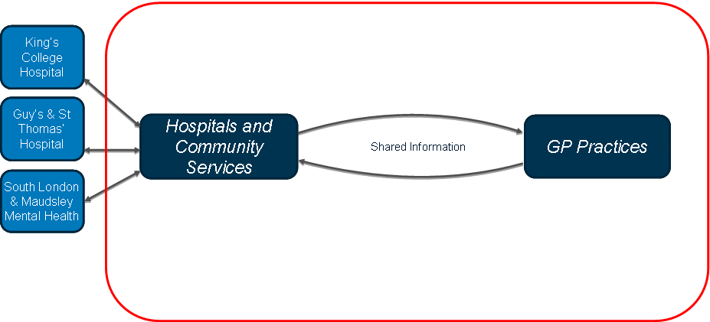
Information is only shared when it is needed to make your care and treatment safer, easier and faster and only with those people directly involved in your care. This could include allowing a hospital doctor to see the medication that a GP has prescribed for you when you go in to hospital or allowing a GP to see what care, tests or treatment you received while in hospital.
Above all it will allow professionals that are supporting you to work with you to make safer and better decisions about your care.
The new system will start to operate in a small number of GP practices and hospital services in August 2015, and other organizations will continue to join during 2015 and 2016.
You can choose for your information not to be shared between your local NHS organizations, but please note that not sharing your information may affect the care you receive.

